1. This time we weekly chart.
2. 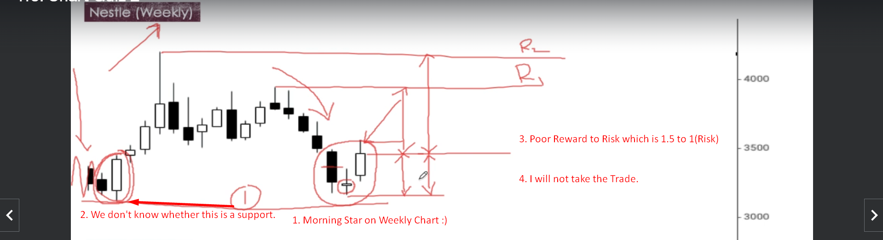
3. 